

Smart Electric Vehicle Charging Network Management Platform
A CASE STUDY REPORT

Submitted in the partial fulfilment for the Course of
CSA1016 – SOFTWARE ENGINEERING
to the award of the degree of
BACHELOR OF ENGINEERING IN
ARTIFICIAL INTELLIGENCE AND DATA SCIENCE

Submitted by
R. R. RAKSHITH (192324156)

Under the Supervision of
Dr. K. Anitha Davamani
SIMATS ENGINEERING
Saveetha Institute of Medical and Technical Sciences Chennai-602105
JUL 2026



SIMATS ENGINEERING
Saveetha Institute of Medical and Technical Sciences Chennai-602105

DECLARATION

I, R. R. Rakshith, of the Department of Artificial Intelligence & Data Science,Saveetha Institute of Medical and Technical Sciences, Saveetha University, Chennai, hereby declare that the Case study work entitled Smart Electric Vehicle Charging Network Management Platform is the result of our own Bonafide efforts. To the best of our knowledge, the work presented herein is original, accurate, and has been carried out in accordance with principles of engineering ethics.

Place: Chennai
Date: 18/02/2026

Signature of the Students with Names
R R RAKSHITH (192324156)

ACKNOWLEDGEMENT

We would like to express our heartfelt gratitude to all those who supported and guided us throughout the successful completion of our Capstone Project. We are deeply thankful to our respected Founder and Chancellor, Dr. N.M. Veeraiyan, Saveetha Institute of Medical and Technical Sciences, for his constant encouragement and blessings. We also express our sincere thanks to our Pro-Chancellor, Dr. Deepak Nallaswamy Veeraiyan, and our Vice-Chancellor, Dr. S. Suresh Kumar, for their visionary leadership and moral support during the course of this project.

We are truly grateful to our Director, Dr. Ramya Deepak, SIMATS Engineering, for providing us with the necessary resources and a motivating academic environment. Our special thanks to our Principal, Dr. B. Ramesh for granting us access to the institute’s facilities and encouraging us throughout the process. We sincerely thank our Head of the Department, Dr.Anusuya for her continuous support, valuable guidance, and constant motivation.

We are especially indebted to our guide, Dr. K. Anitha Davamani for her creative suggestions, consistent feedback, and unwavering support during each stage of the project. We also express our gratitude to the Project Coordinators, Review Panel Members (Internal and External), and the entire faculty team for their constructive feedback and valuable inputs that helped improve the quality of our work. Finally, we thank all faculty members, lab technicians, our parents, and friends for their continuous encouragement and support.

Signature With Student Name

R R RAKSHITH (192324156)

ABSTRACT

The rapid global shift from internal combustion engine (ICE) vehicles to Electric Vehicles (EVs) has been driven by rising fuel costs, environmental concerns, and stricter emission regulations. However, as EV adoption accelerates, the charging infrastructure supporting it remains fragmented and largely manual — charging stations operate as isolated units with no shared visibility of availability, no advance reservation capability, and inconsistent payment processes across operators. This creates significant inconvenience for EV owners, limits operational insight for station operators, and leaves network administrators without the data needed for effective planning and load management. This case study presents a Smart Electric Vehicle Charging Network Management Platform, a cloud-connected, IoT-enabled software solution designed to unify EV owners, charging station operators, and network administrators within a single coordinated system. The proposed platform integrates real-time station discovery, AI-assisted slot allocation, automated session management, secure digital payment processing, and predictive maintenance, built on a modular microservice-based architecture. The system's design applies core software engineering principles — modularity, scalability, reliability, usability, security, and maintainability — and is supported by UML-based architectural artifacts, including system architecture, use case, data flow, activity, sequence, class, component, deployment, and entity-relationship diagrams. An Agile (Scrum) development methodology is proposed to accommodate the platform's evolving requirements and support iterative, modular delivery. The expected outcomes include reduced range anxiety for EV owners, improved station utilization and uptime for operators, and data-driven decision-making for network administrators. The study concludes that a unified, intelligent software platform can effectively bridge the current gaps in EV charging infrastructure, supporting broader EV adoption and more efficient, sustainable urban mobility.

TABLE OF CONTENTS

SNO | TOPIC | Page No
1 | ABSTRACT | 5
2 | INTRODUCTION | 7-9
3 | PROBLEM IDENTIFICATION AND ANALYSIS | 10-12
4 | SOLUTION DESIGN AND IMPLEMENTATION | 13-16
5 | RESULTS AND RECOMMENDATION | 17-18
6 | REFLECTION ON LEARNING AND PERSONAL DEVELOPMENT | 19-20
7 | CONCLUSION | 21-22
8 | REFERENCES | 23
9 | APPENDICES | 24-41

Chapter 1: Introduction

1.1 Background: From Internal Combustion to Electric Mobility
For over a century, personal and commercial mobility was built almost entirely around the internal combustion engine (ICE). Petrol and diesel vehicles offered quick refuelling and an established fuel-distribution network, but they came with two costs that became harder to ignore over time: dependence on imported crude oil and continuous emission of greenhouse gases and particulate pollutants. As urban air quality worsened and climate commitments tightened, automakers, governments, and energy companies began a structural shift towards Electric Vehicles (EVs).
The transition did not happen overnight. Early EV attempts in the late 19th and early 20th centuries lost out to ICE vehicles because of limited battery range and long charging times. It was only with the maturing of lithium-ion battery technology in the 2000s, combined with government incentives, stricter emission norms, and falling battery costs, that EVs became commercially viable at scale. Manufacturers such as Tesla, Tata Motors, MG, Hyundai, BYD, and others pushed EV adoption into the mainstream over the last decade, and Indian metropolitan cities have seen a sharp rise in EV two-wheelers, three-wheelers, and passenger cars.

1.2 Growth of Charging Infrastructure
As EV ownership grows, the bottleneck has shifted from the vehicle itself to the charging ecosystem around it. Early charging infrastructure was fragmented: individual charge point operators (CPOs) installed stations with little coordination, no shared visibility of availability, and largely manual, cash- or card-based payment processes. EV owners routinely faced problems such as not knowing which stations were free, arriving at a station only to find it occupied or faulty, and having no way to plan a long trip around charging stops.
This has created industry-wide demand for a unified, technology-driven charging network management platform — one that can bring EV owners, charging station operators, and administrators onto a single digital system supported by IoT-enabled hardware, cloud infrastructure, and data analytics.

1.3 Industry Context
Globally and in India, the EV charging infrastructure market is expanding rapidly, driven by government schemes (such as the FAME scheme and state EV policies), private investment from energy companies and startups, and partnerships between automakers and charging network operators. Smart charging platforms are increasingly expected to support real-time station discovery, dynamic slot reservation, remote diagnostics, load balancing across the electrical grid, and integrated billing — capabilities that traditional, hardware-only charging stations cannot provide on their own.

1.4 Introduction to the Proposed Platform
This report proposes and analyses a Smart Electric Vehicle Charging Network Management Platform — a cloud-connected software system that unifies EV owners, charging station operators, and network administrators through a mobile application, IoT-enabled charging stations, and a cloud-based backend. The platform focuses on real-time station discovery, AI-assisted slot allocation, automated payment processing, and data-driven analytics for network planning and predictive maintenance.
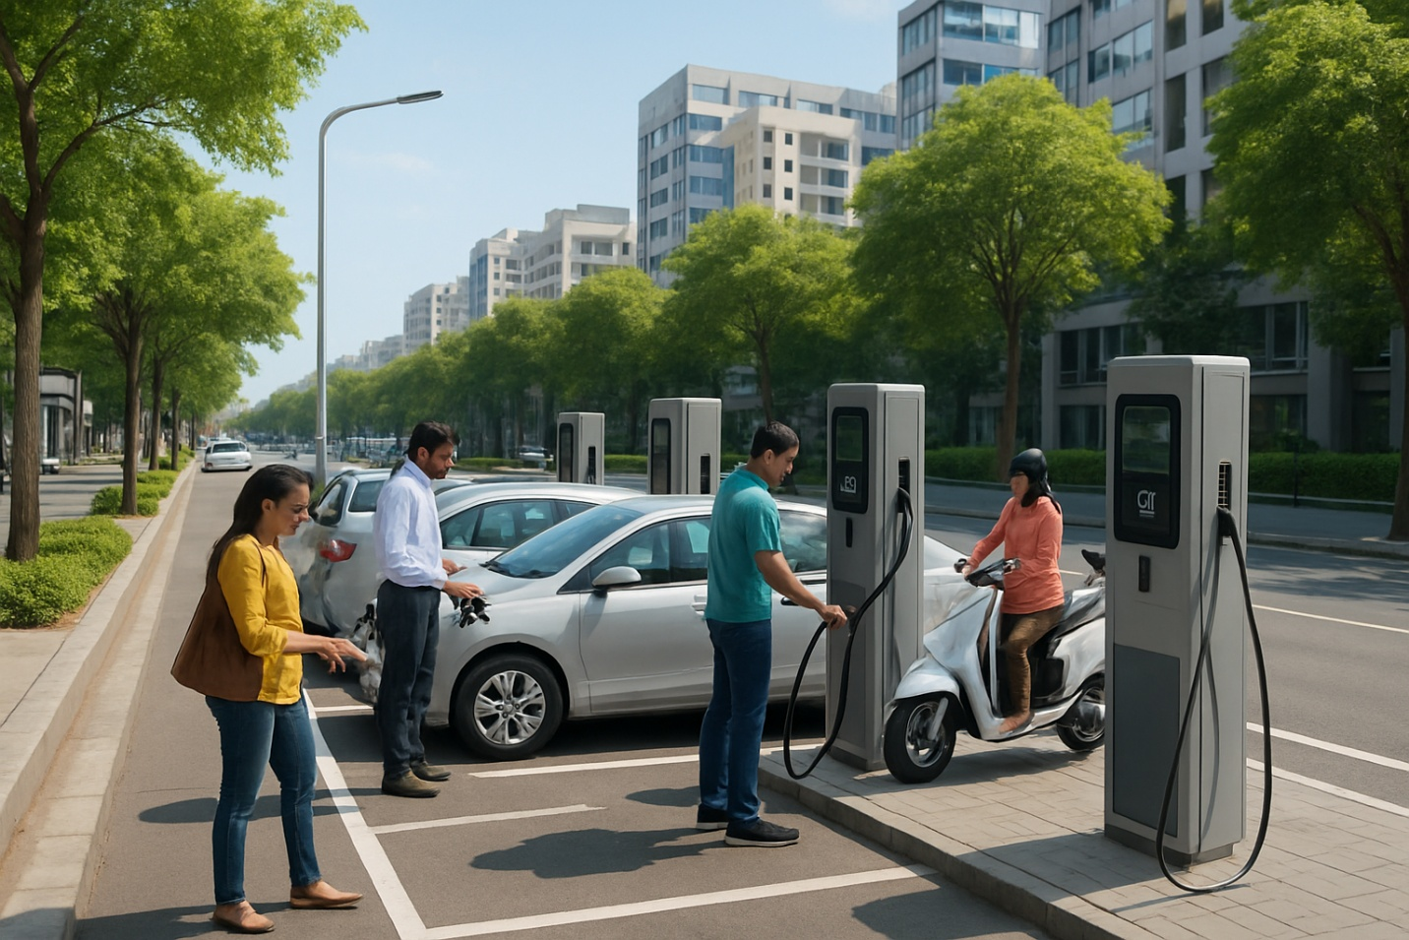
The remainder of this report follows a systematic software engineering case study structure: understanding the problem, identifying stakeholders and challenges, analysing the current (largely manual) approach, proposing a software solution with supporting UML/architecture diagrams, justifying a suitable SDLC methodology, and finally discussing expected outcomes, risks, and future enhancements.

Chapter 2: Understanding the Problem Statement

2.1 Problem Statement (In Own Words)
As the number of electric vehicles on the road increases, EV owners struggle to find available, working charging stations near them. Existing charging points are largely disconnected from one another — there is no shared, real-time view of which stations are free, which are occupied, and which are under maintenance. Owners often waste time and battery range travelling to a station only to discover it is unavailable, and once there, they may have to wait in a queue with no way to reserve a slot in advance. Payment is frequently manual and inconsistent across operators, and network administrators lack the data needed to plan new stations, balance electrical load, or anticipate equipment failures. The problem, therefore, is the absence of an integrated, intelligent, software-driven system that connects EV owners, charging station hardware, and network operators/administrators into a single coordinated platform.

2.2 Objectives of the Proposed System
- Provide EV owners with real-time visibility of nearby charging stations, including availability, connector type, and pricing.
- Enable advance reservation of charging slots to eliminate uncertainty and queuing.
- Automate the charging session lifecycle — authentication, session start/stop, and energy metering.
- Provide secure, automated, and transparent digital payment and invoicing.
- Give station operators and administrators real-time monitoring, fault alerts, and predictive maintenance insights.
- Generate analytics and reports to support data-driven network expansion and load-balancing decisions.
- Ensure the platform is scalable, secure, and reliable enough to support a growing national charging network.

2.3 Scope of the Problem
The scope of this case study covers the software system that manages the EV charging network — the mobile and web applications, backend services, IoT communication layer, and data analytics components. It includes station discovery, reservation, session management, payment, monitoring, and reporting functionality. The scope excludes the physical design and electrical engineering of the charging hardware itself, the civil infrastructure for installing stations, and grid-level power generation planning; these are treated as external systems that the platform integrates with rather than replaces.
Chapter 3: Key Stakeholders and Challenges

3.1 Identified Stakeholders
- EV Owners / Drivers — the primary end users who search for, reserve, and use charging stations, and make payments.
- Charging Station Operators (CPOs) — individuals or companies that own and operate physical charging stations and need to monitor usage, revenue, and equipment health.
- Network Administrators — manage the overall platform: onboarding new stations, managing users, viewing analytics, and configuring pricing/policies.
- Field Maintenance / Service Technicians — respond to faults and scheduled maintenance flagged by the system.
- Payment Gateway Providers — third-party financial services that process transactions on behalf of the platform.
- Electricity Distribution Companies (DISCOMs) / Grid Operators — indirectly involved, since large-scale charging affects local grid load.
- Regulatory Bodies / Government Agencies — set standards for EV charging (connector types, safety, data protection) that the platform must comply with.

3.2 Roles and Responsibilities
- EV Owners: search for stations, reserve slots, initiate/stop charging sessions, make payments, and provide feedback/ratings.
- Station Operators: keep stations operational, respond to maintenance alerts, update station availability, and review station-level revenue reports.
- Administrators: manage the master list of stations and users, configure pricing and promotions, monitor overall network health, and generate network-wide reports.
- Technicians: receive fault tickets generated automatically by the system and update repair status.
- Payment Gateway: authorizes and settles transactions securely, and returns confirmation to the platform.

3.3 Major Challenges Faced by Stakeholders
- EV owners face 'range anxiety' amplified by uncertainty over station availability, leading to wasted trips and time.
- Operators lack real-time visibility into equipment health, so faults are often discovered by a frustrated customer rather than proactively.
- Administrators cannot easily correlate usage data across stations to decide where new stations are needed or where load-balancing is required.
- Inconsistent or manual payment processes across different operators create friction and reduce customer trust.
- Sudden spikes in simultaneous charging can overload local electrical infrastructure if not monitored and managed.
- Data privacy and security concerns arise from handling location data, payment information, and vehicle usage patterns.
Chapter 4: Analysis of the Current Approach

4.1 Description of the Existing System / Current Process
In most current deployments, EV charging stations operate largely as independent, standalone units. An EV owner typically has to rely on generic maps, word-of-mouth, or a manufacturer-specific app that only lists that brand's stations. There is little to no advance reservation capability, and payment is handled locally at each station — sometimes by cash, sometimes through a card reader or a QR code specific to that single operator.
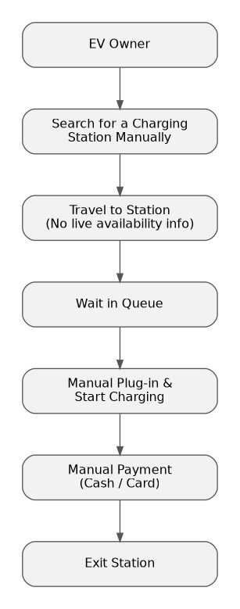
Figure 4.1: Existing (Manual / Fragmented) EV Charging Workflow

4.2 Strengths of the Existing Approach
- Simple to deploy for a single operator with a small number of stations.
- Low upfront software/IT investment for the station owner.
- Works even with minimal connectivity, since many stations only need local control logic.

4.3 Limitations of the Existing Approach
- No real-time, cross-operator visibility of station availability for the EV owner.
- No advance slot reservation — owners must physically travel and hope a charger is free.
- Manual or fragmented payment systems across different operators create inconsistent user experience.
- Operators have no automated way to detect faults remotely; issues are usually reported by frustrated customers.
- No centralized analytics for network planning, demand forecasting, or load balancing.
- Little to no predictive maintenance — components fail unexpectedly, causing downtime.
- Limited scalability: adding stations does not automatically improve the customer experience because stations remain isolated from one another.

4.4 Gaps That Need to Be Addressed
The core gap is the lack of a unifying software layer. The physical hardware to charge a vehicle already exists; what is missing is the intelligent coordination layer that connects owners, stations, and administrators, enables planning ahead of time, automates payment, and turns raw usage data into actionable insight. This gap is precisely what the proposed Smart EV Charging Network Management Platform is designed to close.

Chapter 5: Proposed Software Solution

5.1 Solution Overview
The proposed solution is a three-tier, cloud-connected platform consisting of (1) a mobile application for EV owners and a web dashboard for operators/administrators, (2) a cloud-hosted backend of microservices handling booking, AI-based allocation, session management, payments, and analytics, and (3) IoT-enabled charging stations that communicate station status and telemetry back to the cloud in real time.
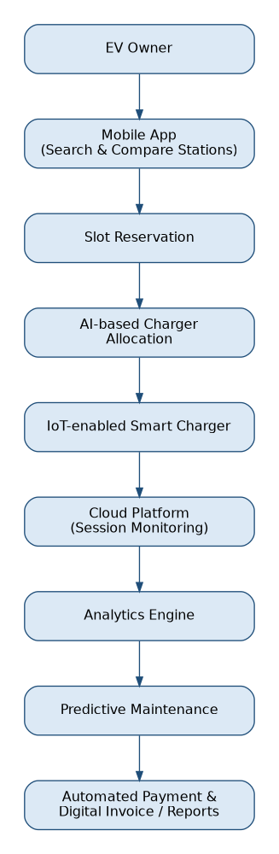
Figure 5.1: Proposed Smart EV Charging Workflow

5.2 Major Functional Modules
- User & Authentication Module — registration, login, role-based access (EV Owner, Operator, Admin).
- Station Discovery & Search Module — real-time map-based search with filters for connector type, charging speed, and price.
- AI-Based Allocation & Recommendation Module — recommends the best available station/slot based on location, live occupancy, and predicted demand.
- Booking & Reservation Module — allows advance reservation and cancellation of charging slots.
- Charging Session Management Module — authenticates the vehicle at the station (QR/RFID), starts/stops the session, and streams telemetry (energy consumed, duration).
- Payment & Billing Module — calculates cost, processes payment via a payment gateway, and generates a digital invoice.
- Monitoring & Predictive Maintenance Module — tracks the health of each charger, raises fault alerts, and predicts likely failures using historical sensor data.
- Analytics & Reporting Module — provides administrators with dashboards on usage trends, revenue, peak demand periods, and network expansion recommendations.

5.3 Functional Requirements
- The system shall allow EV owners to search for charging stations within a specified radius and view real-time availability.
- The system shall allow EV owners to reserve, modify, and cancel a charging slot in advance.
- The system shall authenticate a vehicle/user at a charging station before permitting a charging session to start.
- The system shall record energy consumption and session duration for each charging session.
- The system shall calculate charges automatically and process payment through an integrated payment gateway.
- The system shall notify station operators and technicians automatically when a fault is detected.
- The system shall generate usage, revenue, and maintenance reports for administrators.

5.4 Non-Functional Requirements
- Scalability: the platform must support a growing number of stations and concurrent users without performance degradation.
- Reliability: charging sessions and payment transactions must complete correctly even under network interruptions (offline/retry handling).
- Availability: the platform should target high uptime (e.g., 99.9%) given its role in daily mobility.
- Security: user data, location data, and payment information must be encrypted in transit and at rest, with role-based access control.
- Usability: the mobile app and dashboard must be simple and accessible for a wide range of users, including first-time EV owners.
- Maintainability: the modular microservice design should allow individual modules to be updated independently.
- Interoperability: the platform should support multiple connector standards and integrate with third-party payment gateways and mapping services.

5.5 Software Engineering Principles Applied
- Modularity: the system is decomposed into independent microservices (booking, payment, analytics, etc.), each with a single, well-defined responsibility, following the Single Responsibility Principle.
- Scalability: stateless microservices behind an API gateway and load balancer allow horizontal scaling as the number of stations and users grows.
- Maintainability: clear separation between the client layer, business logic layer, and data layer means individual services can be modified, tested, and redeployed without affecting the rest of the system.
- Reliability: message queues decouple IoT telemetry ingestion from processing, so temporary spikes or outages in one service do not directly bring down others.
- Usability: a consistent, minimal-step user interface for search-to-charge-to-pay reduces cognitive load for EV owners.
- Security: authentication/authorization is centralized in a dedicated service, data is encrypted, and all external integrations (payment, IoT) occur over secured channels.

5.6 System Architecture
The architecture follows a layered, service-oriented design comprising a client layer (mobile app, web dashboard), an API/integration layer (gateway and authentication), an application/business-logic layer (independent microservices), a data layer (relational database, time-series database, and message queue), and a field/IoT layer (smart charging stations and the external payment gateway).
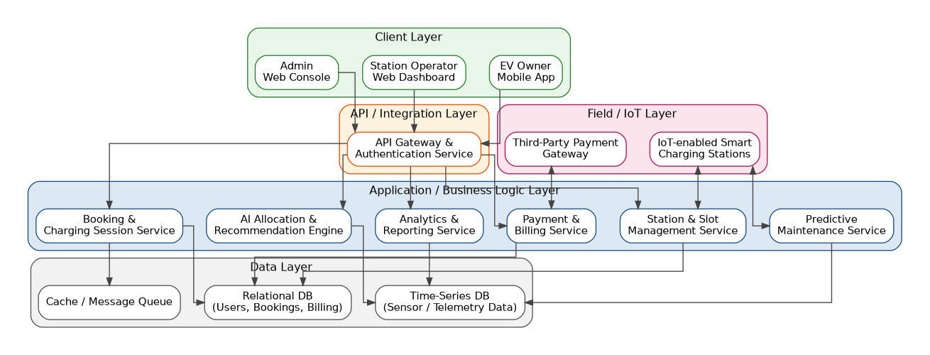
Figure 5.2: System Architecture Diagram

5.7 Use Case Diagram
The use case diagram below captures the key interactions between the three primary actors (EV Owner, Station Operator, System Admin) and the external Payment Gateway with the platform's core use cases.
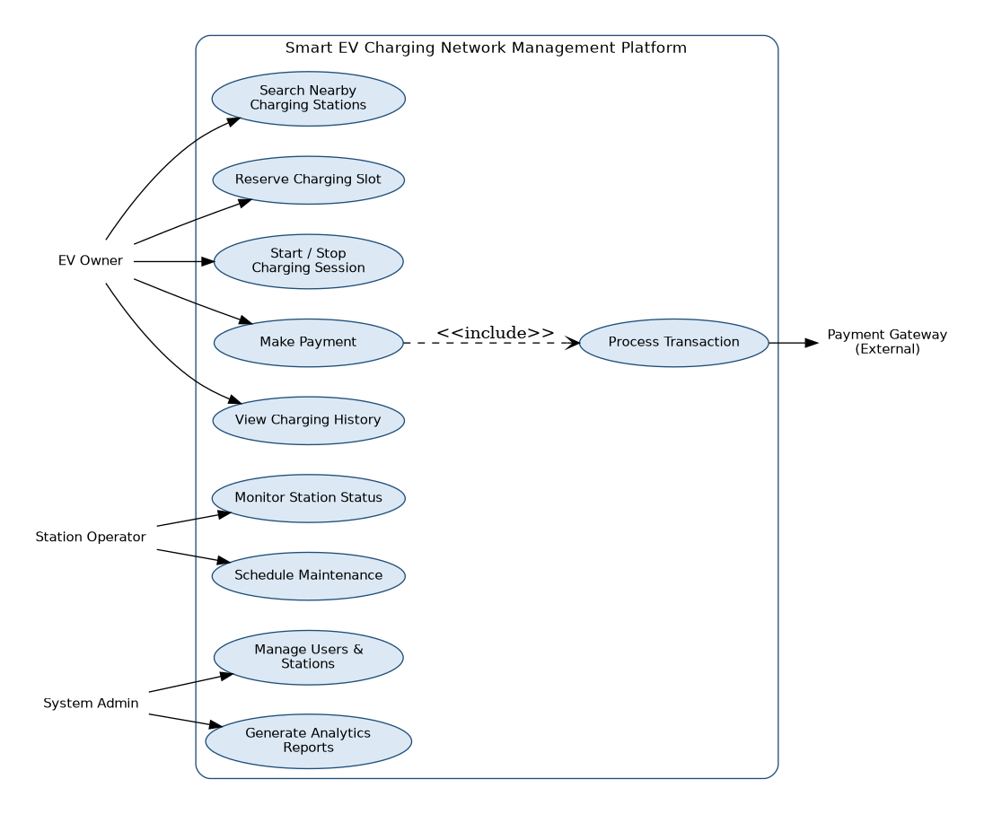
Figure 5.3: Use Case Diagram

5.8 Data Flow Diagram — Level 0 (Context Diagram)
The Level 0 DFD treats the platform as a single process and shows the high-level flow of data between the platform and its external entities.
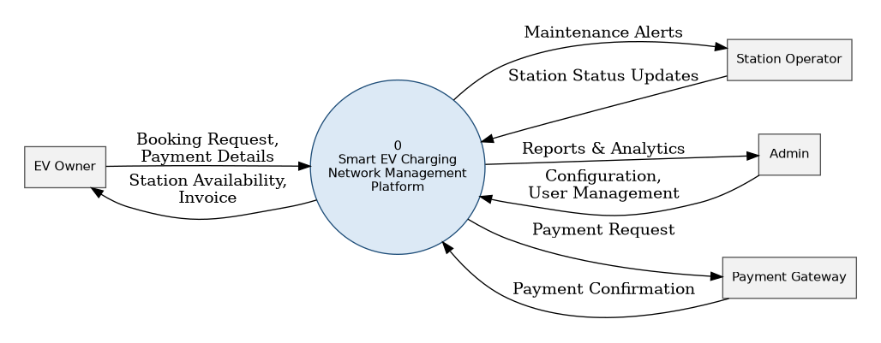
Figure 5.4: DFD Level 0 (Context Diagram)

5.9 Data Flow Diagram — Level 1
The Level 1 DFD decomposes the platform into its core processes — authentication, station search & booking, charging session management, payment processing, and analytics & reporting — along with the data stores each process reads from or writes to.
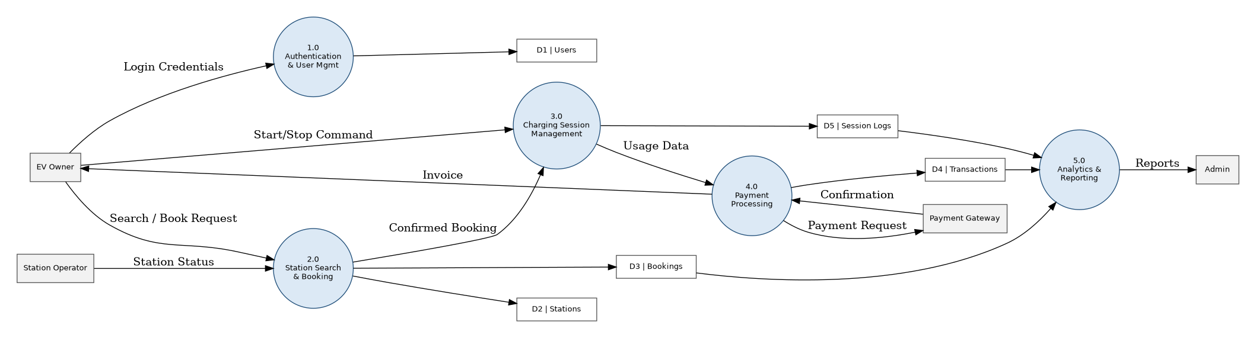
Figure 5.5: DFD Level 1

5.10 Activity Diagram
The activity diagram traces the end-to-end workflow an EV owner follows, from logging into the mobile app through to searching, reserving, charging, and paying — including the decision points for slot availability and charging completion.
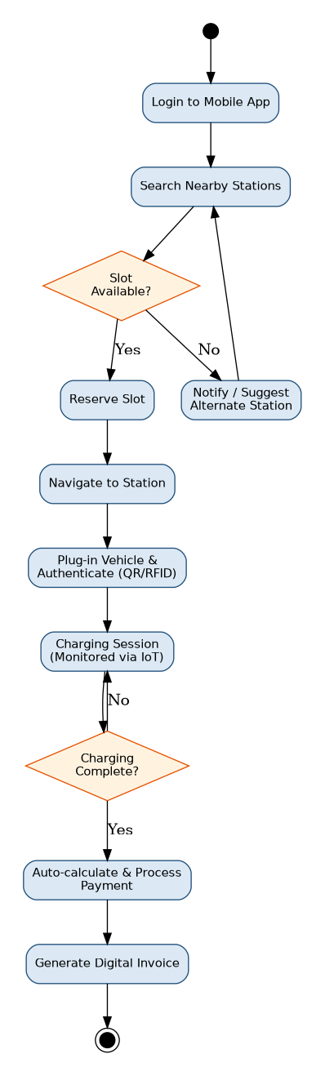
Figure 5.6: Activity Diagram — EV Charging Workflow

5.11 Sequence Diagram
The sequence diagram illustrates the reservation-to-charging process, showing the interaction sequence between the EV Owner's mobile app, the Booking Service, the AI Allocation Engine, the Charging Station, and the Payment Gateway.
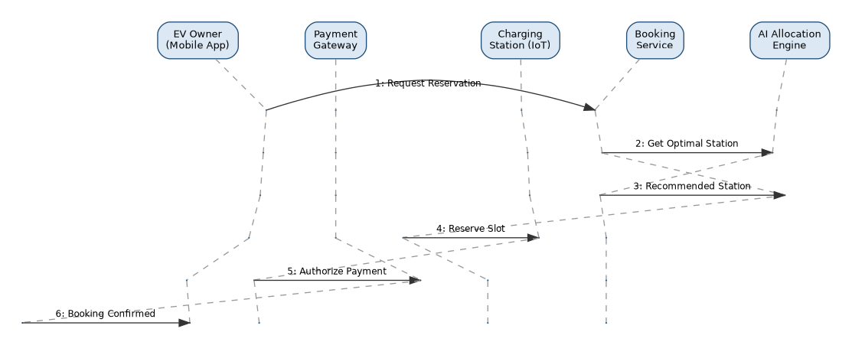
Figure 5.7: Sequence Diagram — Reservation to Charging Process

5.12 Class Diagram
The class diagram models the core domain entities of the platform and their relationships, including inheritance between the generic User class and its EVOwner/Admin specializations, and associations between Booking, ChargingStation, ChargingSession, and Payment.
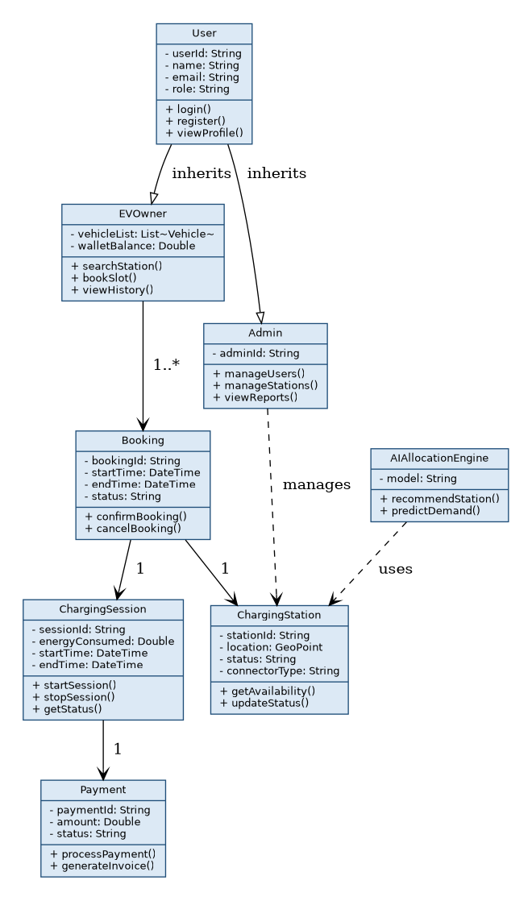
Figure 5.8: Class Diagram

5.13 Component Diagram
The component diagram shows the platform's major software components and their dependencies, from the client-facing Mobile App and Web Dashboard through the API Gateway to the backend service components and the shared database.
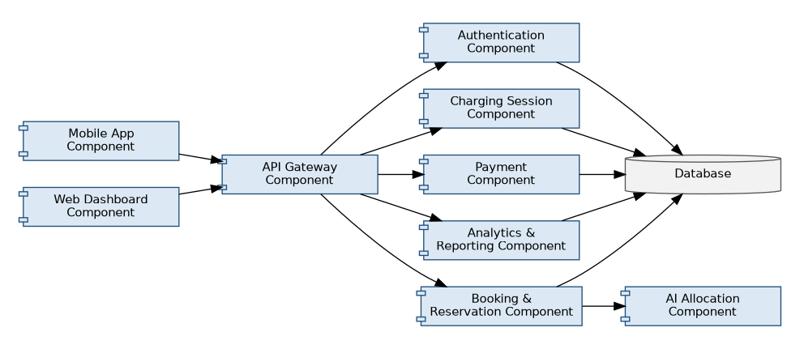
Figure 5.9: Component Diagram

5.14 Deployment Diagram
The deployment diagram maps the software components onto physical/virtual nodes: the client device, the IoT edge controller at each charging station, the cloud server node running the microservices and AI inference engine, and the external payment gateway server.
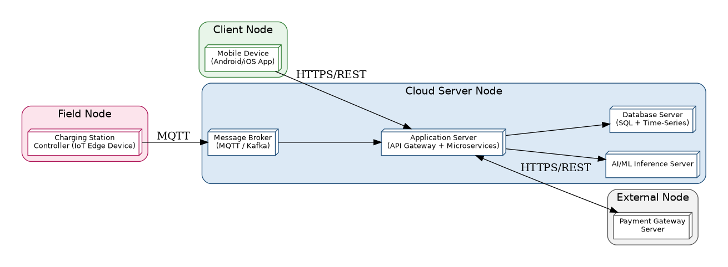
Figure 5.10: Deployment Diagram

5.15 Entity-Relationship (ER) Diagram
The ER diagram models the platform's core database schema — Users, Vehicles, Stations, Connectors, Bookings, Sessions, and Payments — along with their primary/foreign key relationships.
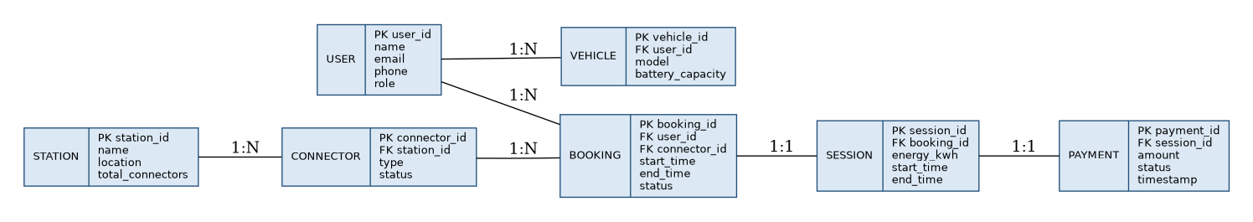
Figure 5.11: Entity-Relationship Diagram

Chapter 6: Justification of the Chosen Methodology / Framework

6.1 Selected Methodology: Agile (Scrum Framework)
The Agile Scrum framework is selected as the software development methodology for the Smart EV Charging Network Management Platform.

6.2 Justification
- Evolving requirements: EV charging is a fast-evolving domain (new connector standards, changing government regulations, new payment methods), and Agile's iterative sprints allow the platform to adapt without a costly redesign, unlike a rigid Waterfall approach.
- Independent modules: because the platform is built as loosely-coupled microservices (booking, payment, analytics, IoT ingestion, etc.), different Scrum teams can work on separate modules in parallel sprints.
- Early and continuous feedback: EV owners and station operators can pilot early increments (e.g., station search before full AI allocation is ready) and provide feedback that shapes subsequent sprints.
- Risk reduction: high-risk components such as IoT integration and payment processing can be prioritized in early sprints and validated with working software rather than being discovered late in a Waterfall-style final testing phase.
- Continuous delivery culture: Agile aligns naturally with DevOps practices (CI/CD, automated testing) which suit a cloud-hosted platform that needs frequent, low-risk updates.

6.3 How Agile/Scrum Supports Development and Maintenance
Work is organized into a prioritized product backlog (e.g., station search, booking, payment, analytics) executed in 2–3 week sprints, each ending with a potentially shippable increment. Daily stand-ups keep cross-functional teams (mobile, backend, IoT, data) synchronized, sprint reviews validate features with stakeholders (including pilot station operators), and sprint retrospectives drive continuous process improvement. Post-launch, the same Scrum cadence is used to roll out new features (e.g., support for new connector types, improved AI allocation models) and to respond quickly to production issues.

Chapter 7: Expected Outcomes and Limitations

7.1 Expected Benefits
- Reduced time and uncertainty for EV owners in finding and using a charging station.
- Higher station utilization and revenue for operators through better visibility and demand-based allocation.
- Reduced downtime through predictive maintenance and automated fault alerts.
- Faster, more consistent, and more transparent digital payments across the entire network.
- Data-driven decisions for network expansion, pricing, and load balancing, based on real analytics rather than guesswork.
- A better overall EV ownership experience, which indirectly supports wider EV adoption and environmental goals.

7.2 How the Solution Addresses the Identified Challenges
Real-time station discovery and reservation directly address range anxiety and wasted trips. Automated fault detection and predictive maintenance resolve operators' lack of visibility into equipment health. Centralized analytics give administrators the network-wide view they previously lacked for planning and load balancing, and a unified payment module removes the friction of inconsistent, operator-specific payment processes.

7.3 Potential Risks, Implementation Challenges, and Limitations
- Integration complexity: connecting a wide variety of existing charger hardware (from different manufacturers) to a single IoT communication standard can be technically challenging.
- Connectivity dependence: rural or low-connectivity areas may see degraded real-time features if network coverage at the station is poor.
- Data privacy and security: handling location, usage, and payment data at scale increases the platform's responsibility and regulatory exposure (e.g., data protection laws).
- Adoption risk: the platform's value depends on a critical mass of stations and users joining the network; low initial adoption limits its usefulness.
- Grid load management: coordinating simultaneous high-power charging sessions with the local electricity grid requires ongoing collaboration with DISCOMs and is only partially solvable in software.
- Cost of AI/analytics infrastructure: maintaining accurate demand-prediction and predictive-maintenance models requires continuous data collection and periodic retraining, which adds operational overhead.

7.4 Suggested Future Enhancements
- Dynamic, demand-based pricing that adjusts charging cost based on real-time grid load and station demand.
- Route-based trip planning that automatically schedules charging stops for long-distance EV journeys.
- Deeper integration with renewable energy sources (e.g., solar-powered charging stations) and battery storage for greener charging.
- Vehicle-to-Grid (V2G) support, allowing EVs to feed stored energy back into the grid during peak demand.
- Loyalty and subscription-based pricing models to encourage repeat usage and long-term customer retention.

Chapter 8: Conclusion

The rapid global transition from internal combustion engine vehicles to electric vehicles has created an urgent need for a charging infrastructure that is as intelligent and connected as the vehicles it supports. This case study examined the core problem plaguing current EV charging systems — fragmented, isolated charging stations with no real-time visibility, no reservation capability, inconsistent payment processes, and no centralized data for network planning — and proposed a comprehensive, software-driven solution to address it. The proposed Smart Electric Vehicle Charging Network Management Platform brings EV owners, charging station operators, and network administrators onto a single, cloud-connected system. By integrating real-time station discovery, AI-assisted slot allocation, IoT-enabled monitoring, automated payment processing, predictive maintenance, and centralized analytics, the platform directly resolves the inefficiencies of the current manual approach. Its modular, microservice-based architecture ensures the system remains scalable, secure, maintainable, and reliable as the charging network grows, while the adoption of an Agile/Scrum development methodology allows the platform to evolve alongside changing regulations, hardware standards, and user expectations.

The analysis carried out through this case study — spanning problem identification, stakeholder mapping, current system evaluation, solution design, and architectural modelling — demonstrates that the challenges faced by EV owners, operators, and administrators are not primarily hardware limitations but a lack of coordinated software intelligence. By addressing this gap, the proposed platform has the potential to significantly improve the EV charging experience, increase station utilization and uptime, reduce operational costs through predictive maintenance, and provide the data-driven insight needed for sustainable network expansion.

Ultimately, this solution does more than solve a technical inconvenience — it removes one of the key barriers to wider EV adoption. A dependable, transparent, and intelligent charging network builds the confidence drivers need to switch to electric vehicles, supporting broader environmental goals and the long-term shift towards sustainable urban mobility.

References
- International Energy Agency (IEA), Global EV Outlook — trends in electric mobility and charging infrastructure.
- Ministry of Heavy Industries, Government of India — FAME India Scheme documentation.
- Sommerville, I., Software Engineering, Pearson Education — SDLC models and software engineering principles.
- Object Management Group (OMG) — Unified Modeling Language (UML) Specification, for diagram notation standards.

